DATA STRUCTURE



Lab Tasks

By
Muhammad Hilal Khattak
FA25-BCS-022

Submitted to,
Mr. Bilal Bukhari

Department of Computer Sciences

Task 1

#include <iostream>
using namespace std;

int main()
{
int start, stop;
long long sum = 0;

cout << "Enter starting value: ";
cin >> start;

cout << "Enter stopping value: ";
cin >> stop;

// Calculate sum of squares
for (int x = start; x <= stop; x++)
{
sum = sum + (x * x);
}

cout << "\nSum of X^2 = " << sum << endl;

return 0;
}
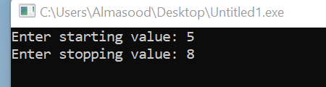

Task 2

#include <iostream>
using namespace std;

const int MAX_SIZE = 100;

class ArrayList
{
private:
int arr[MAX_SIZE];
int size;

public:
// Constructor
ArrayList()
{
size = 0;
}

// 1. Insert value at the end
void insertAtEnd(int value)
{
if (size == MAX_SIZE)
{
cout << "List is full!" << endl;
return;
}

arr[size] = value;
size++;

cout << "Value inserted at end." << endl;
}

// 2. Insert value at the start
void insertAtStart(int value)
{
if (size == MAX_SIZE)
{
cout << "List is full!" << endl;
return;
}

// Shift elements to the right
for (int i = size; i > 0; i--)
{
arr[i] = arr[i - 1];
}

arr[0] = value;
size++;

cout << "Value inserted at start." << endl;
}

// 3. Insert value after a specific value
void insertAfter(int specificValue, int newValue)
{
if (size == MAX_SIZE)
{
cout << "List is full!" << endl;
return;
}

int position = -1;

// Find specific value
for (int i = 0; i < size; i++)
{
if (arr[i] == specificValue)
{
position = i;
break;
}
}

if (position == -1)
{
cout << "Specific value not found!" << endl;
return;
}

// Shift elements to the right
for (int i = size; i > position + 1; i--)
{
arr[i] = arr[i - 1];
}

arr[position + 1] = newValue;
size++;

cout << "Value inserted after " << specificValue << "." << endl;
}

// 4. Insert value before a specific value
void insertBefore(int specificValue, int newValue)
{
if (size == MAX_SIZE)
{
cout << "List is full!" << endl;
return;
}

int position = -1;

// Find specific value
for (int i = 0; i < size; i++)
{
if (arr[i] == specificValue)
{
position = i;
break;
}
}

if (position == -1)
{
cout << "Specific value not found!" << endl;
return;
}

// Shift elements to the right
for (int i = size; i > position; i--)
{
arr[i] = arr[i - 1];
}

arr[position] = newValue;
size++;

cout << "Value inserted before " << specificValue << "." << endl;
}

// 5. Display the array list
void display()
{
if (size == 0)
{
cout << "List is empty!" << endl;
return;
}

cout << "Array List: ";

for (int i = 0; i < size; i++)
{
cout << arr[i] << " ";
}

cout << endl;
}

// 6. Delete value from the end
void deleteFromEnd()
{
if (size == 0)
{
cout << "List is empty!" << endl;
return;
}

cout << "Deleted value: " << arr[size - 1] << endl;

size--;
}

// 7. Delete value from the start
void deleteFromStart()
{
if (size == 0)
{
cout << "List is empty!" << endl;
return;
}

cout << "Deleted value: " << arr[0] << endl;

// Shift elements to the left
for (int i = 0; i < size - 1; i++)
{
arr[i] = arr[i + 1];
}

size--;
}

// 8. Delete specific value
void deleteSpecific(int value)
{
if (size == 0)
{
cout << "List is empty!" << endl;
return;
}

int position = -1;

// Find the value
for (int i = 0; i < size; i++)
{
if (arr[i] == value)
{
position = i;
break;
}
}

if (position == -1)
{
cout << "Value not found!" << endl;
return;
}

// Shift elements to the left
for (int i = position; i < size - 1; i++)
{
arr[i] = arr[i + 1];
}

size--;

cout << "Value " << value << " deleted successfully." << endl;
}
};

int main()
{
ArrayList list;
int choice;
int value;
int specificValue;

do
{
cout << "\n========== ARRAY LIST MENU ==========" << endl;
cout << "1. Insert value at end" << endl;
cout << "2. Insert value at start" << endl;
cout << "3. Insert value after specific value" << endl;
cout << "4. Insert value before specific value" << endl;
cout << "5. Display array list" << endl;
cout << "6. Delete value from end" << endl;
cout << "7. Delete value from start" << endl;
cout << "8. Delete specific value" << endl;
cout << "0. Exit" << endl;
cout << "=====================================" << endl;

cout << "Enter your choice: ";
cin >> choice;

switch (choice)
{
case 1:
cout << "Enter value: ";
cin >> value;
list.insertAtEnd(value);
break;

case 2:
cout << "Enter value: ";
cin >> value;
list.insertAtStart(value);
break;

case 3:
cout << "Enter specific value: ";
cin >> specificValue;

cout << "Enter new value: ";
cin >> value;

list.insertAfter(specificValue, value);
break;

case 4:
cout << "Enter specific value: ";
cin >> specificValue;

cout << "Enter new value: ";
cin >> value;

list.insertBefore(specificValue, value);
break;

case 5:
list.display();
break;

case 6:
list.deleteFromEnd();
break;

case 7:
list.deleteFromStart();
break;

case 8:
cout << "Enter value to delete: ";
cin >> value;

list.deleteSpecific(value);
break;

case 0:
cout << "Program ended." << endl;
break;

default:
cout << "Invalid choice!" << endl;
}

} while (choice != 0);

return 0;
}

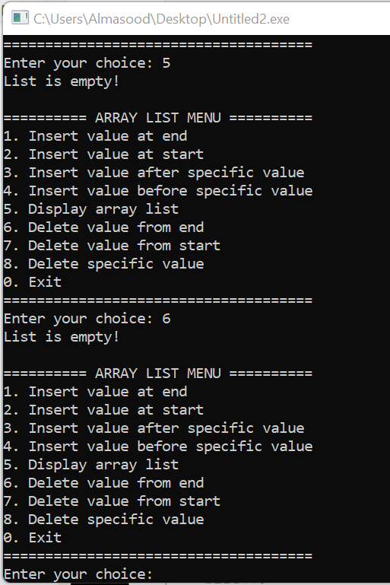
Task 3
#include <iostream>
using namespace std;

const int MAX_SIZE = 100;

class ArrayList
{
private:
int arr[MAX_SIZE];
int size;

public:
// Constructor
ArrayList()
{
size = 0;
}

// Insert value at end
void insertAtEnd(int value)
{
if (size == MAX_SIZE)
{
cout << "List is full!" << endl;
return;
}

arr[size] = value;
size++;
}

// Display list
void display()
{
if (size == 0)
{
cout << "List is empty!" << endl;
return;
}

cout << "Array List: ";

int i = 0;

while (i < size)
{
cout << arr[i] << " ";
i++;
}

cout << endl;
}

// Linear Search using while loop
int linearSearch(int value)
{
int i = 0;

while (i < size)
{
if (arr[i] == value)
{
return i;
}

i++;
}

return -1;
}
};

int main()
{
ArrayList list;

int n;
int value;
int searchValue;
int result;

cout << "How many values do you want to enter? ";
cin >> n;

if (n > MAX_SIZE)
{
cout << "Maximum size is " << MAX_SIZE << "." << endl;
return 0;
}

// Input values
for (int i = 0; i < n; i++)
{
cout << "Enter value " << i + 1 << ": ";
cin >> value;

list.insertAtEnd(value);
}

cout << "\n";
list.display();

// Search value
cout << "\nEnter value to search: ";
cin >> searchValue;

result = list.linearSearch(searchValue);

if (result != -1)
{
cout << "Value " << searchValue
<< " found at index " << result << "." << endl;
cout << "Position in list: " << result + 1 << "." << endl;
}
else
{
cout << "Value " << searchValue
<< " was not found in the list." << endl;
}

return 0;
}
